

**By**

**Sunil Raj Thota  
ALY6110 - Data Management and Big Data**

**Class Number: 202135**

**Class Name: Spring 2021 CPS Quarter – Second Half**

**CRN: 80524**

**Week 2 Assignment 1**

**thota.su@northeastern.edu**

**Summary:**

In this Assignment, As per the instructions, I claimed an Azure VM and connected to the Cloudera Express virtual machine. I have gone through the Big Data Platforms like Apache Hive, Hadoop, Apache Impala, Hue to perform analysis. I have also used Cloudera and Hyper V service. I had followed the steps in the Getting Started with Hadoop user guide step by step. All steps were also recorded, with suitable screenshots and explanations for each step and screenshots. I have used HUE to write the SQL queries and fetched the results as per the requirement. The data set is large enough and needs high computational performance machines, for that I have used Azure Lab to access them remotely and made Cloudera VM run accordingly.

**Part 1:**

I have opened this link (<https://labs.azure.com/register/oh98k5w9>) and logged into the Azure Labs.

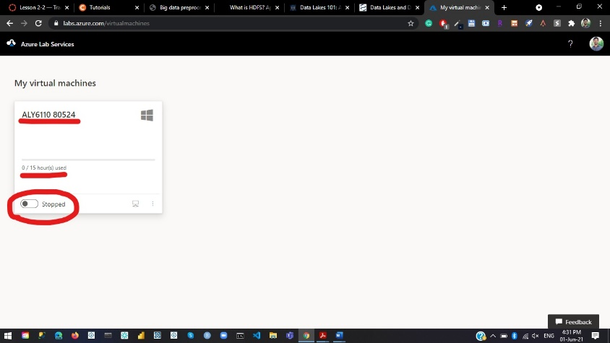

After that, I have clicked on the toggle button to start the virtual machine. This will now go to running state and takes some time to open (Wait for 1 to 7 mins). Once it is up click on the computer icon which is next to it and it will download a rdp file.

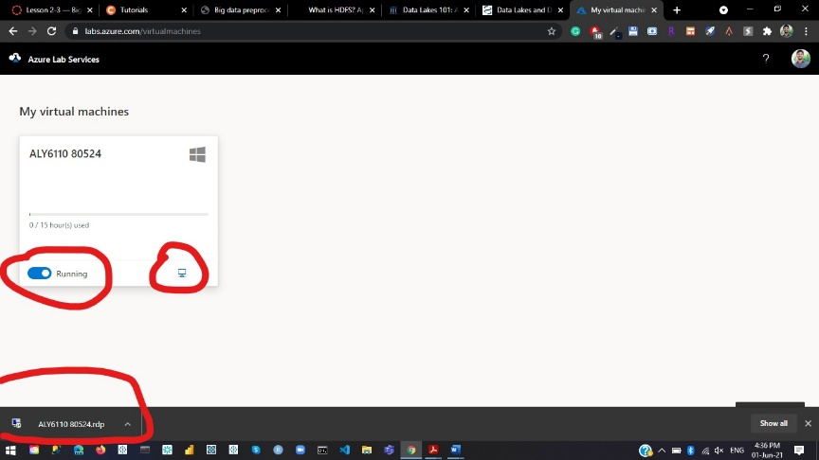

Once it is downloaded, open that file and click on connect button as shown below.

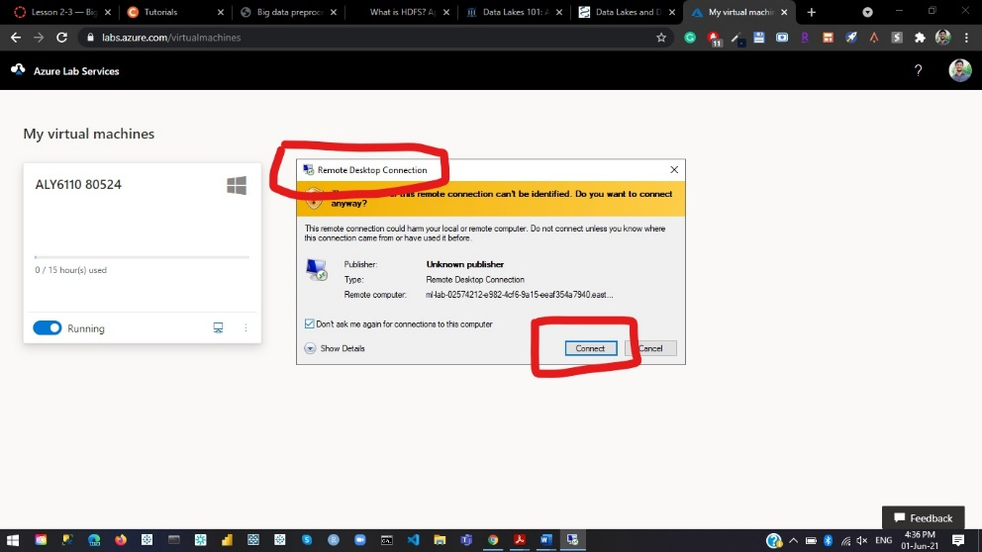

Once you are done with that step, next we have to type the password “**ClassTest2**” to login as shown below and press **OK.**

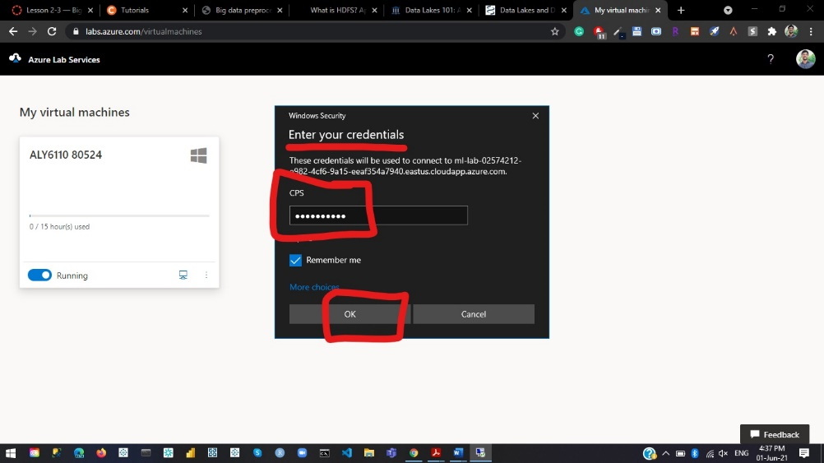

If you get a Remote Desktop Connection Warning labeled in a Yellow Dialog box then, just click on the “**YES**” button and proceed with the next steps.

Now you will see a Virtual Machine opens remotely that you can access for the Assignment purpose. Click on the Hyper -V Manager icon as shown below and a new tab pop up.

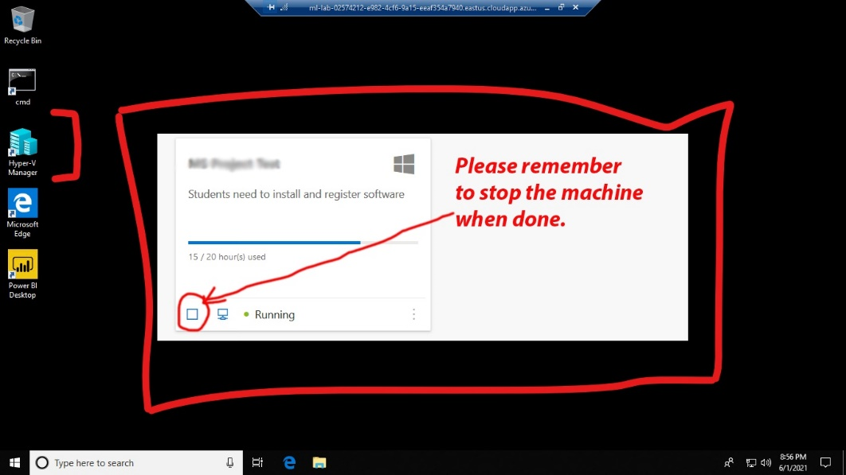

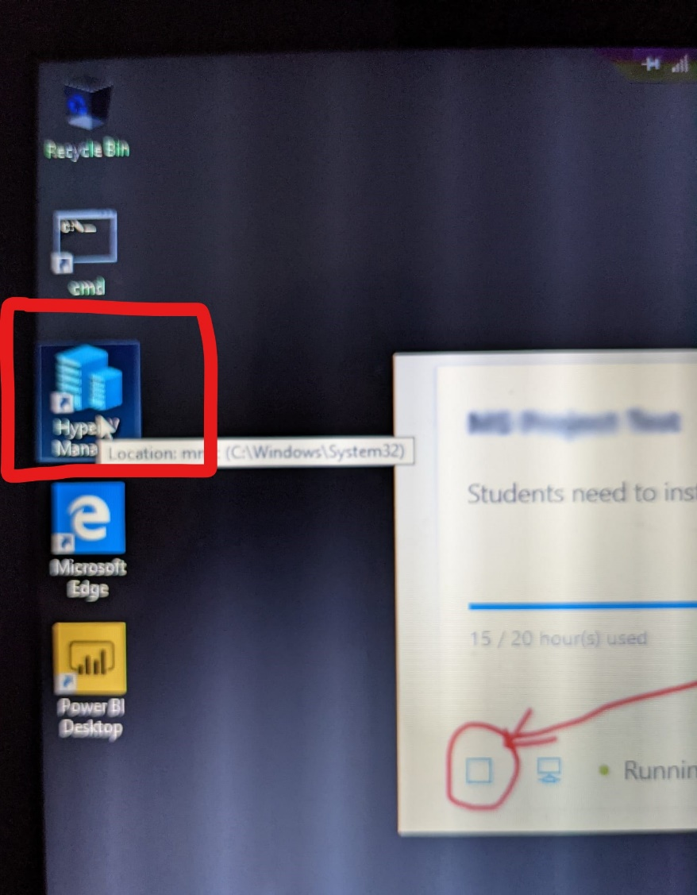

In this, we can see the summary tab, memory tab, and other actions on the right-side bar.

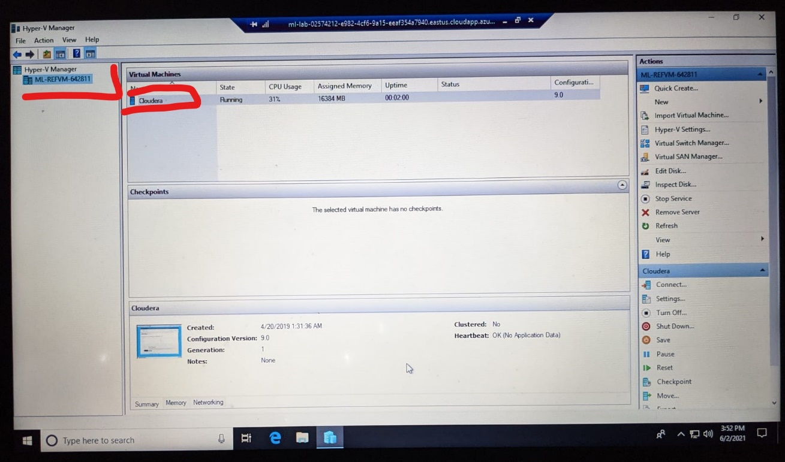

As shown below, click on the start and then on connect button to start the Cloudera that has been pre-installed in this application.

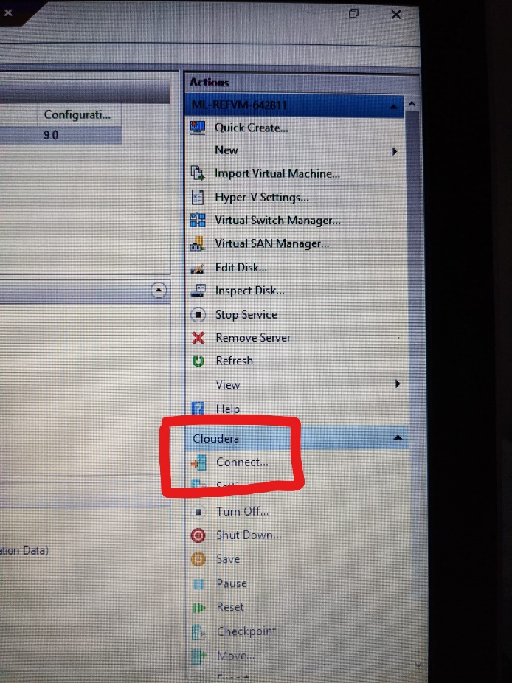

A new window pops up with blue screen named as Cloudera as shown below.



From this we can see a couple of icons that already exists. Let’s click on the Cloudera Express and open it. You may get this terminal and ignore it.

Now let’s open the browser and click on the Cloudera Manager Bookmark Button and it will show up a message that it is attempting to connect to Cloudera Manager… Wait for it and login screen is opened as shown below.

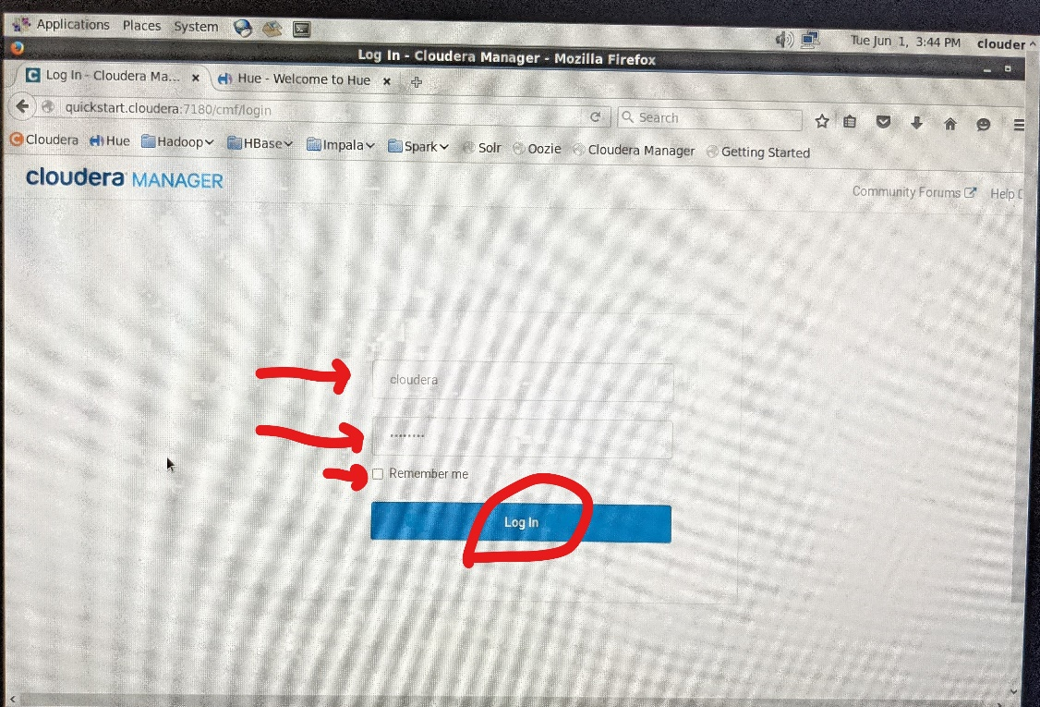

Enter the id and password as ‘**cloudera**’ for both the fields and press login button. Once you are done with this you will be able to see a screen where the services were not yet started and shows an internal error while querying the host monito message in red color.

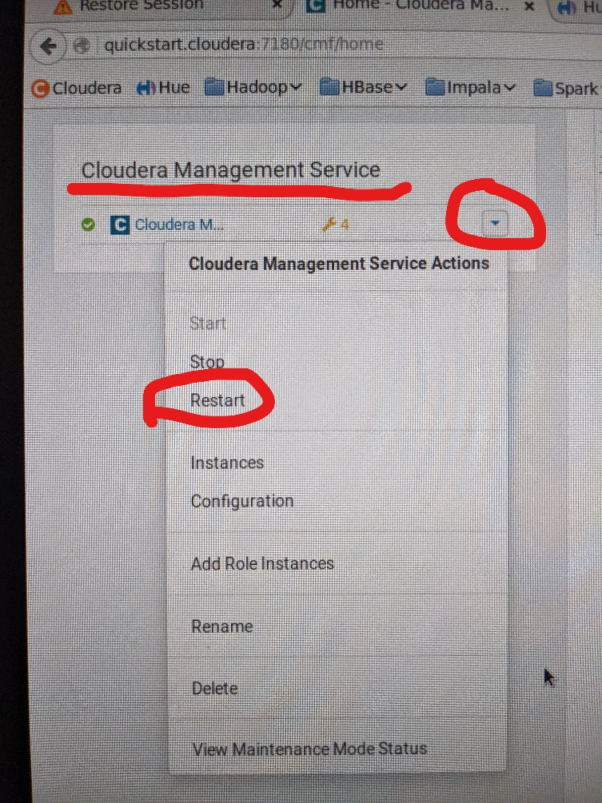

To enable them, simply go to the Cloudera Management Services as shown above and click on the dropdown list and click on the Restart button. Follow the same steps for the Cloudera Quick Start as well as shown below.

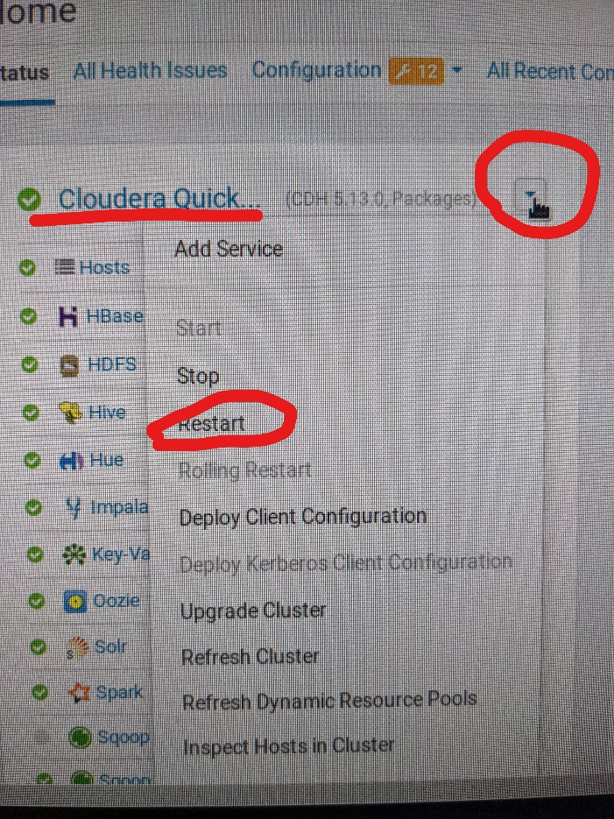

Once it is done you will see that all services in the left side bar with a green tick mark which indicates everything is good so far and all services are enabled.

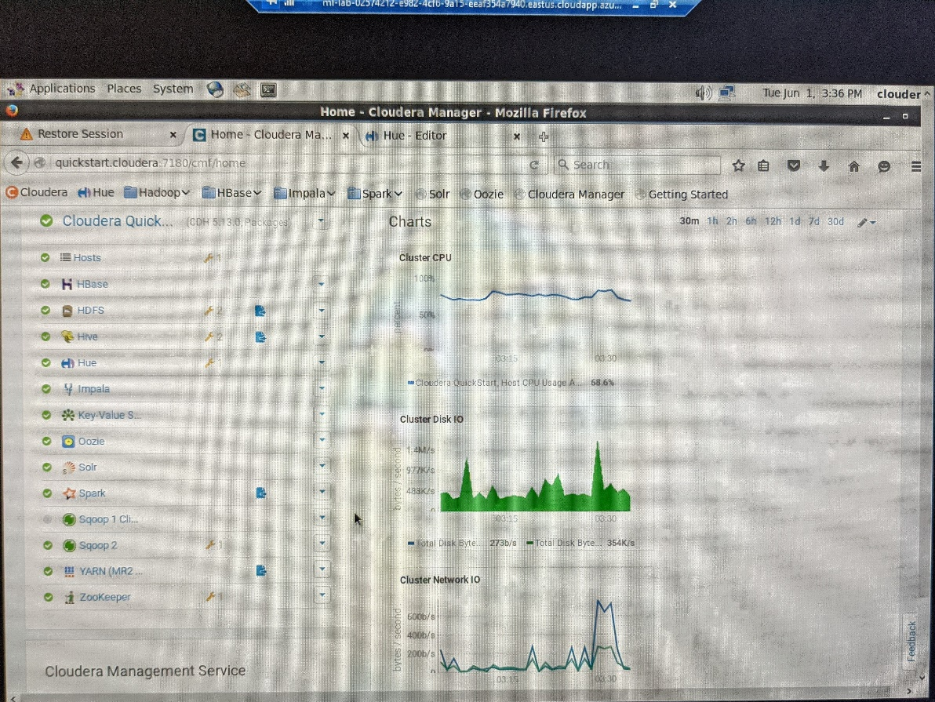

With this Part 1 has been completed. Now, let’s start with the next parts.

**Part 2:**

In this we will use Apache Sqoop to load the data set from MySQL database to the HDFS by running a code snippet in our terminal on the Cloudera Desktop as shown below.

sqoop import-all-tables \

-m 1 \

--connect jdbc:mysql://quickstart:3306/retail_db \

--username=retail_dba \

--password=cloudera \

--as-parquetfile \

--warehouse-dir=/user/hive/warehouse \

--hive-import

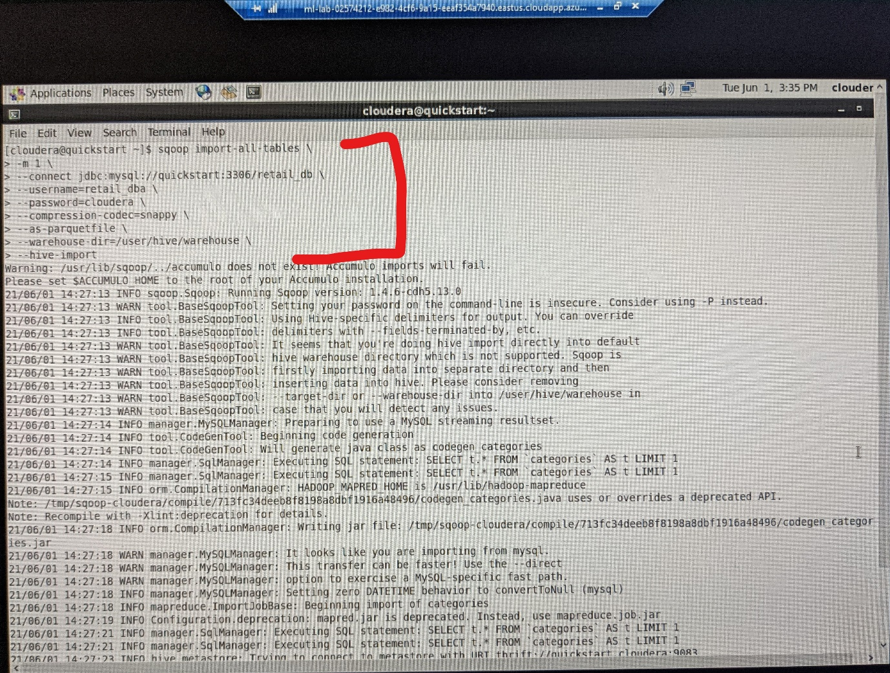

After this step, we can see that the command with quick start directory and it resembles the completion of the job.

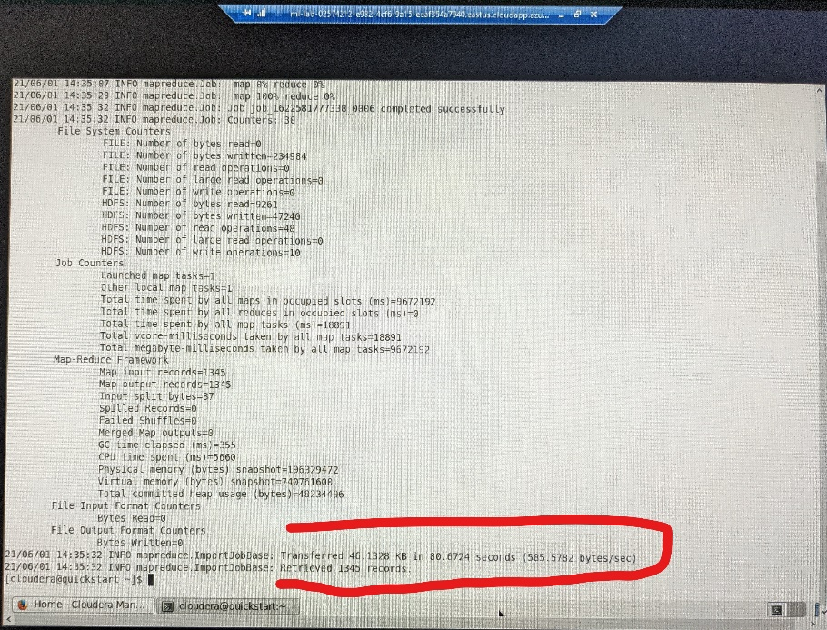

With this snippet, we can check data that has been imported

hadoop fs -ls /user/hive/warehouse/

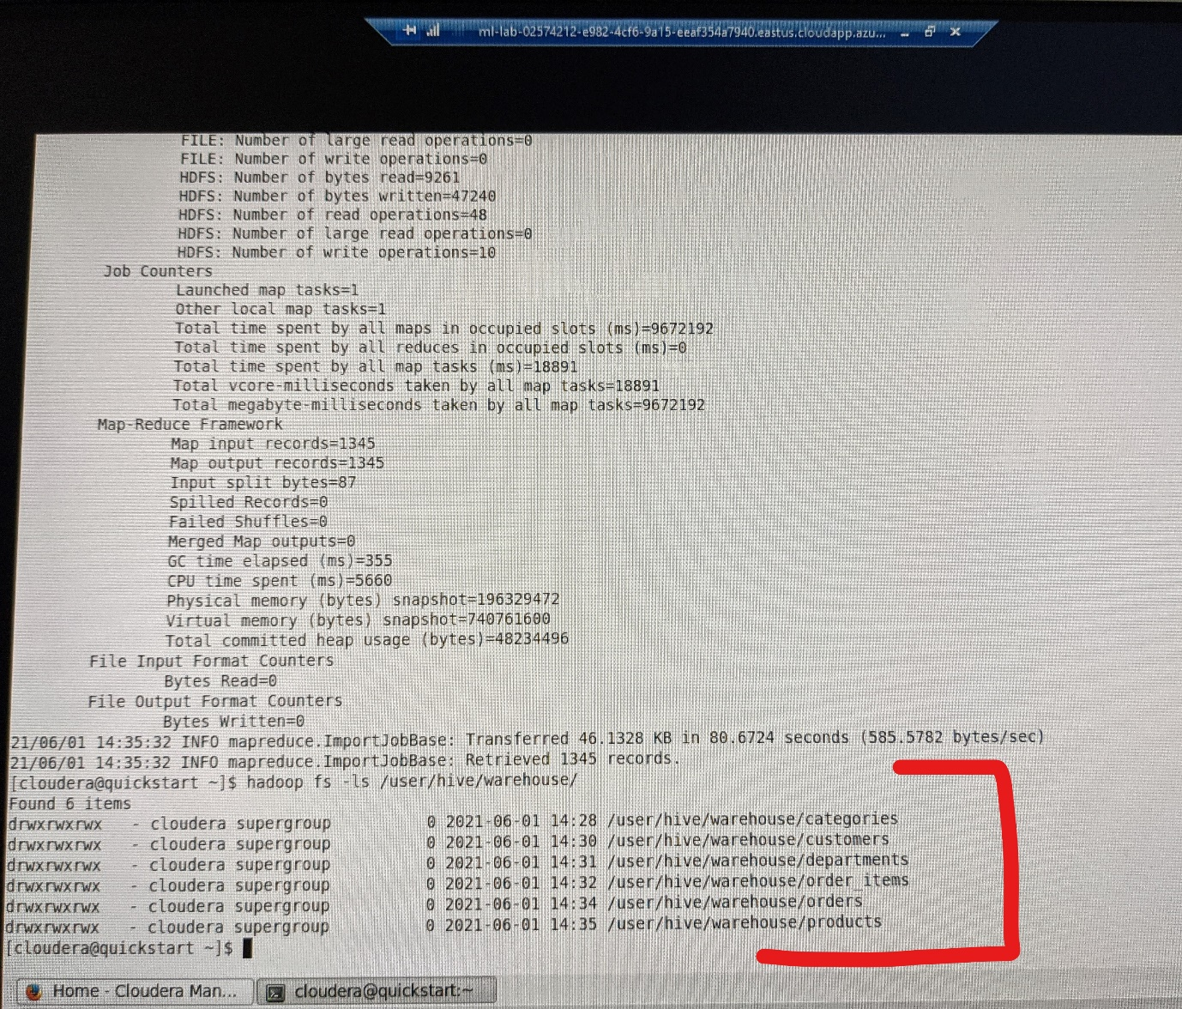

From this we can clearly see that we have fetched 6 tables and let’s perform them on the HUE platform using Impala to write queries.

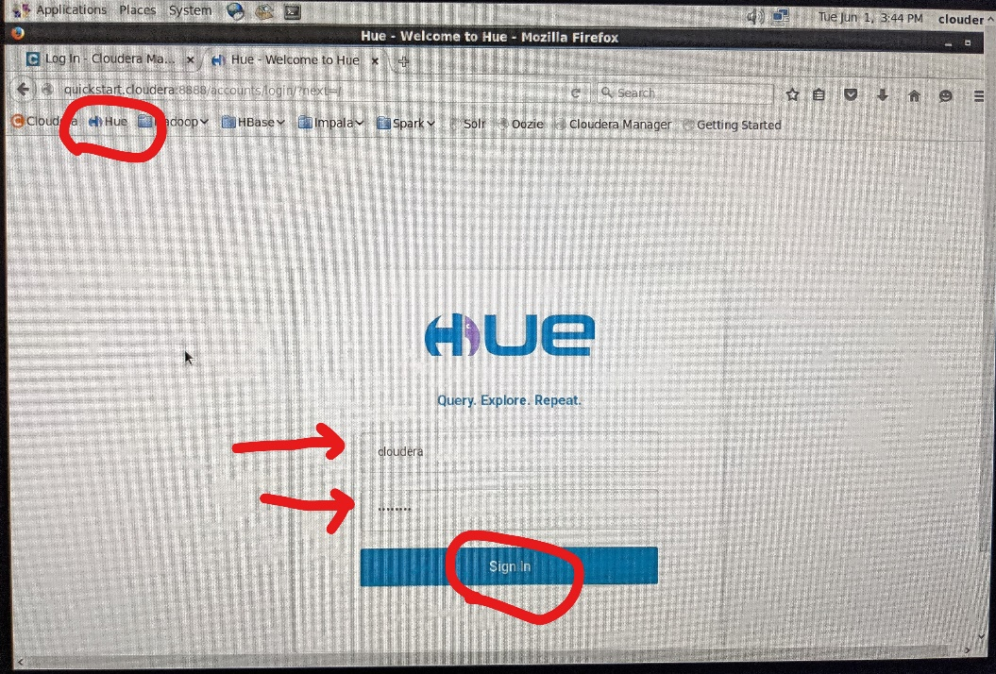

Press on the Hue Bookmark in the tabs shown and Enter the username and password as “**cloudera**” for both the fields and click on the Sign in button.

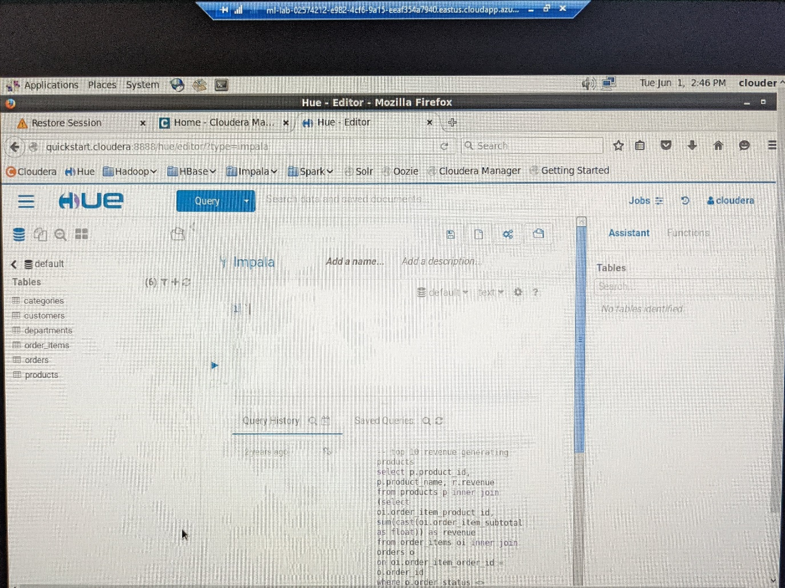

We can see a user interface to write queries and run them accordingly.

Let’s write this query 1st to invalidate the metadata and then show tables.

INVALIDATE METADATA;

SHOW TABLES;

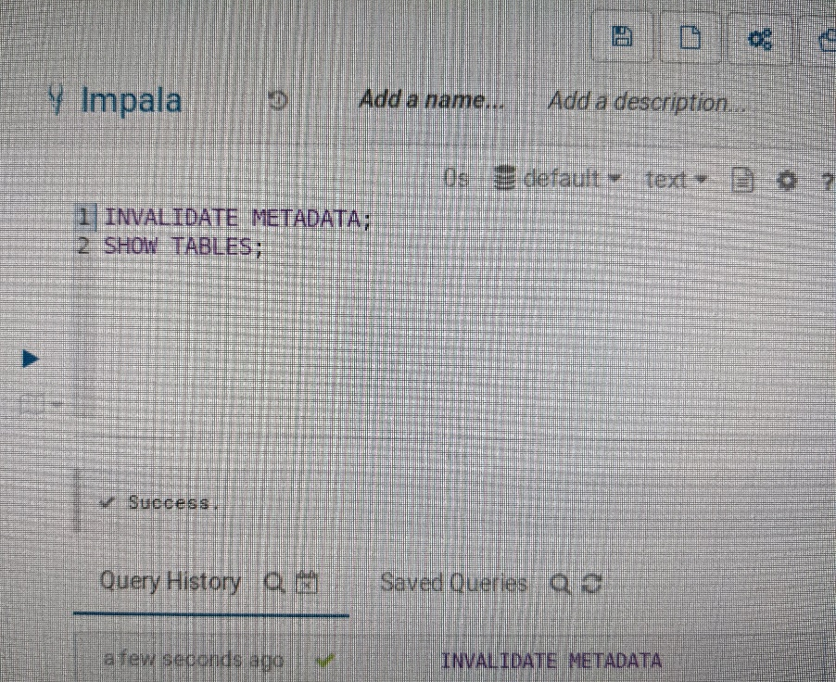

In the next step, lets find out the top 10 most popular product categories with the below code snippet.

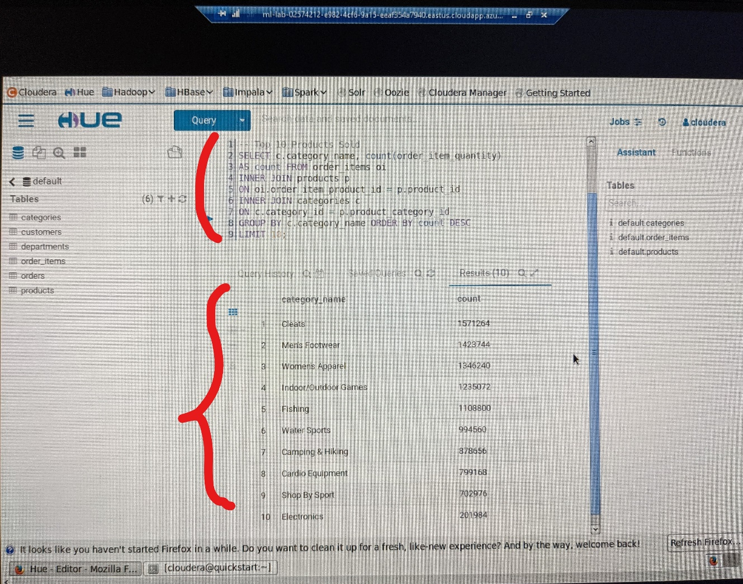

SELECT c.category_name, COUNT(order_item_quantity) AS count

FROM order_items oi INNER JOIN products p

ON oi.order_item_product_id = p.product_id

INNER JOIN categories c

ON c.category_id = p.product_ category_id

GROUP BY c.category_name

ORDER BY count DESC

LIMIT 10;

We can see that the Cleats, Men’s Footwear, and Women’s Apparel as Top 3 which are highly in demand.

Now let’s find out the top 10 revenue generating products

SELECT DISTINCT p.product_id, p.product_name, r.revenue

FROM products p INNER JOIN

(SELECT oi.order_item_product_id, SUM(cast(oi.order_item_ subtotal AS float)) AS revenue

FROM order_items oi

INNER JOIN orders o ON oi.order_item_order_id = o.order_id

WHERE o.order_status <> ‘CANCELED’ AND o.order_status <> ‘SUSPECTED_FRAUD’

GROUP BY order_item_product_id) r ON p.product_id = r.order_item_product_id

ORDER BY r.revenue DESC LIMIT 10;

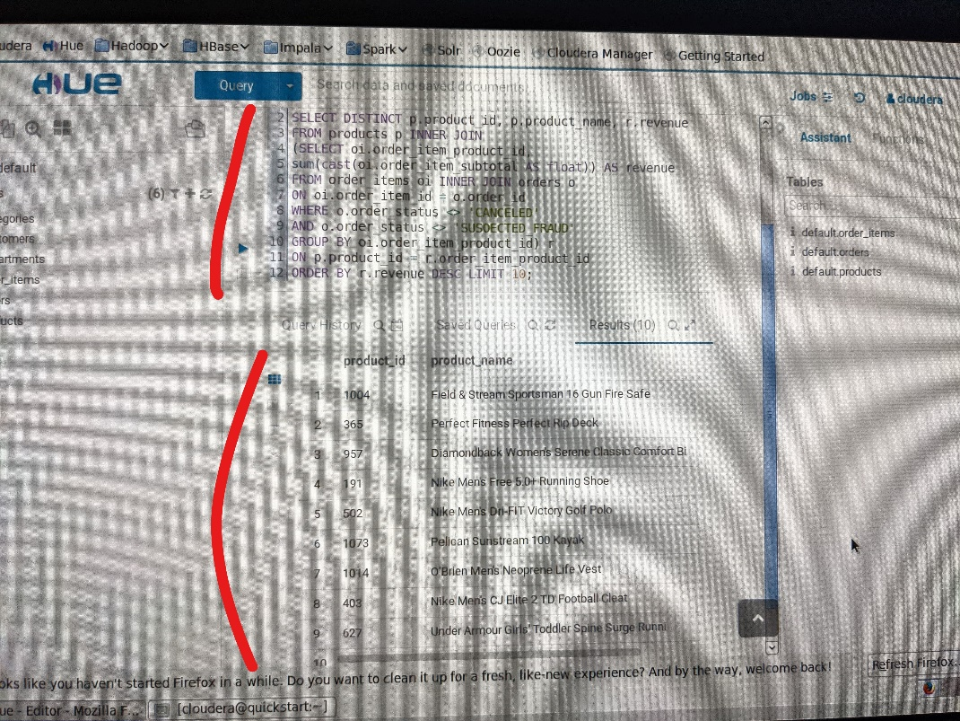

From the above pic we see the list of top 10 revenue generating products. Now let’s start analyzing the Part 3 of the Assignment.

**Part 3:**

**What is the 3rd most popular product category?**

We can see that 3rd most popular product category is Women’s Apparel with 1346240 items

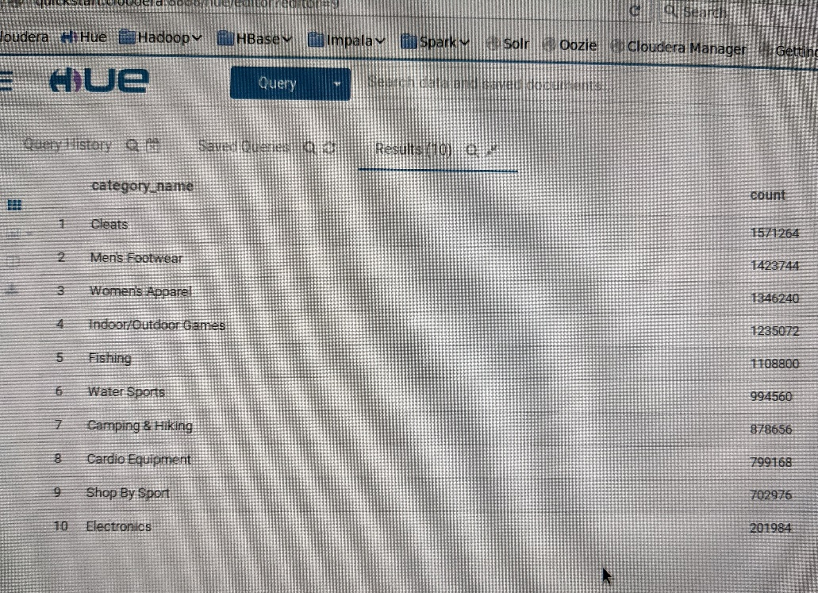

**How much revenue does the Nike Men's Free 5.0+ running shoe earns?**

From the most revenue generating products query we can get the revenue of Nike Men’s Free 5.0+ running shoes as 23501649.570556641

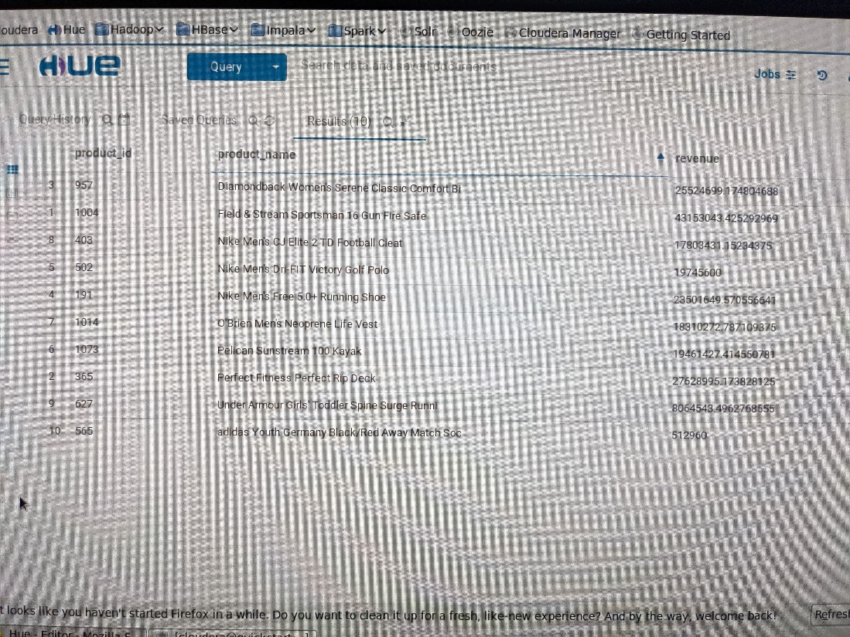

**Modify the query script and provide the product name with the least revenue and how much the revenue amount is?**

Now, let’s modify the query script and sort the product names with ascending order and limit the results to 1.

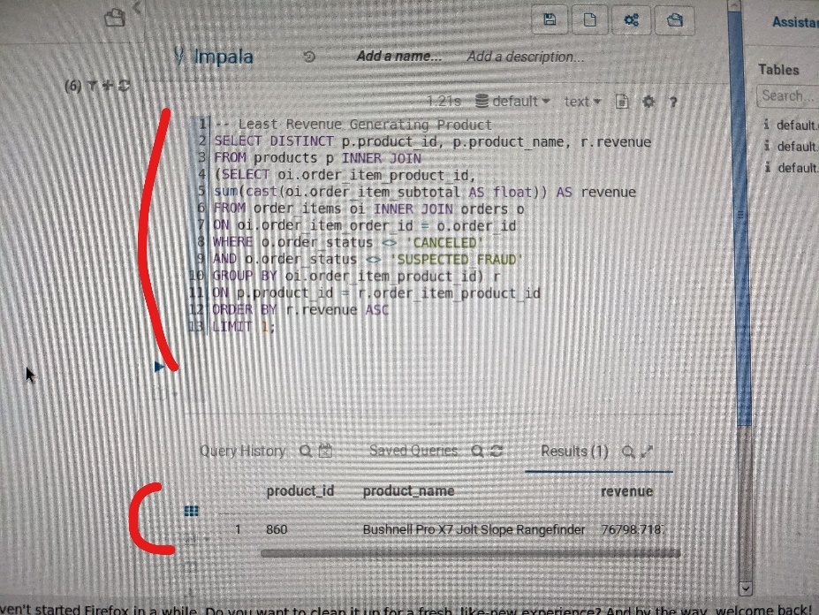

SELECT DISTINCT p.product_id, p.product_name, r.revenue

FROM products p INNER JOIN

(SELECT oi.order_item_product_id, SUM(cast(oi.order_item_ subtotal AS float)) AS revenue

FROM order_items oi

INNER JOIN orders o ON oi.order_item_order_id = o.order_id

WHERE o.order_status <> ‘CANCELED’ AND o.order_status <> ‘SUSPECTED_FRAUD’

GROUP BY order_item_product_id) r

ON p.product_id = r.order_item_product_id

ORDER BY r.revenue ASC LIMIT 1;

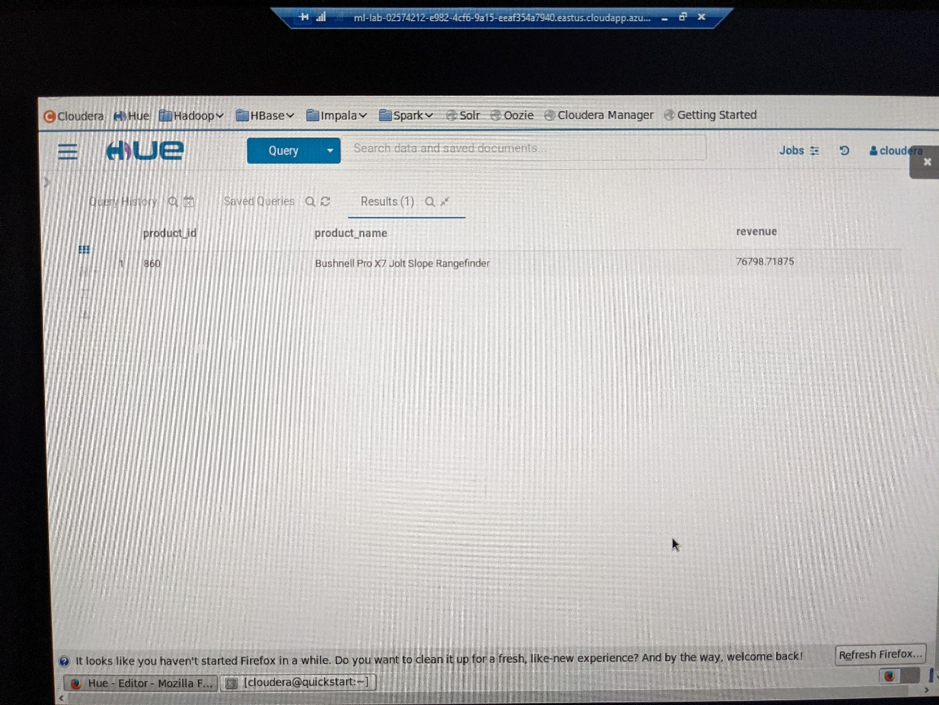

From the above result we can say that the Bushnell Pro X7 Jolt Slope Rangefinder with 76798.71875 in revenue.

After that, I have saved all the queries as shown below.

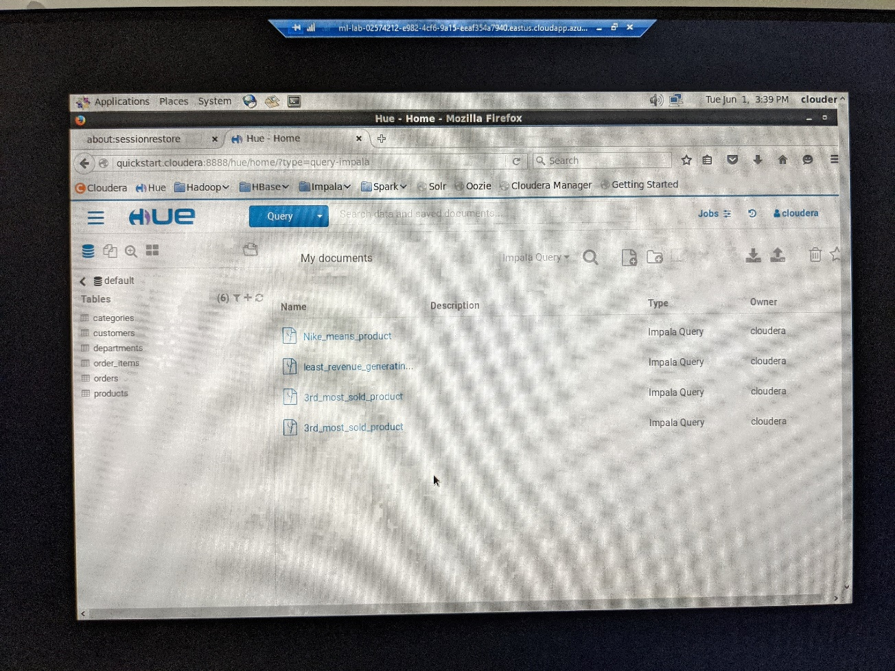

Once all the tasks are done, I have closed, stopped, and shut down all the jobs, applications, and machines and attached the below screenshot as reference for the Virtual Machine that I have stopped after the task.

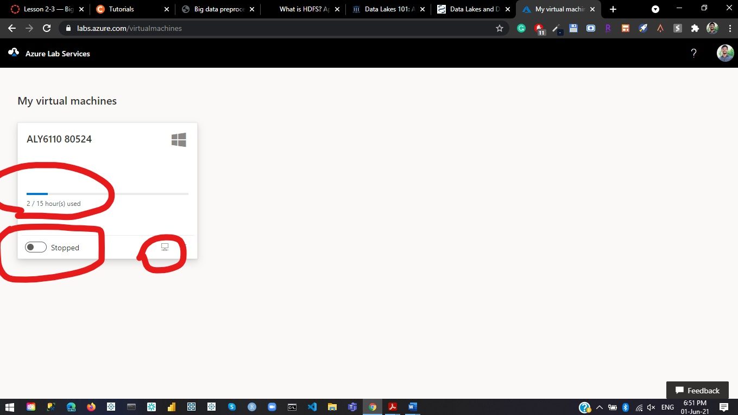

**Analysis:**

This assignment gave me an opportunity to learn and work on the Big Data technologies like Hadoop, Apache Impala, Sqoop, and Hive. I also really like the Azure Virtual Lab setup and instructions that were easy to understand and replicate the steps in a simple way.

**Advantages:**

* Virtual machine was a big plus to run these tasks
* Interactive and fun to learn with easy instructions
* Sqoop handled the data importation by not modifying the query structure
* Hands-on learning

**Disadvantages:**

* May require a greater number of hours and system performance especially for old computers
* Need to change a lot of system settings like display settings, and terminal setup

**Conclusion:**

The ability to perform the same tasks as a big data platform like Hadoop provides more flexibility and cross-platform operability. However, small businesses cannot afford to invest in this because it is too expensive for their needs. A crucial component in the Big Data scenario is the tremendous expansion in data scale that has been noticed in recent years.

To ensure successful data processing and analysis, dealing with big data is a difficult and time-consuming task that necessitates a large infrastructure. Big data is a huge part of data analytics, and harnessing it can be extremely beneficial to anyone for their longer-term uses. Big Data is defined as data with a high volume, velocity, and variety that necessitates new high-performance processing.

**References:**

[1] Salvador García , Sergio Ramírez-Gallego, Julián Luengo, José Manuel Benítez and Francisco Herrera (2016). Big data preprocessing: methods and prospects. *Big Data Analytics.* Retrieved from https://bdataanalytics.biomedcentral.com/track/pdf/10.1186/s41044-016-0014-0.pdf

[2] Cloudera Tutorials (2021). *Cloudera.* Retrieved from https://www.cloudera.com/tutorials.html